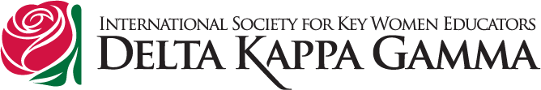
As president of Oregon State Organization of The Delta Kappa Gamma Society International for the 2013-2015 biennium I picked for my theme “Working together ……. Building Early Academic Readiness.” DKG members throughout Oregon are “Working together” with organizations/businesses in their community to help promote “Educational Excellence.” We all know that students need to be ready to learn when they enter school and the best way to accomplish that is to work with families and their young children on enjoying reading together. To promote my theme at the state level, I have created what I call the BEAR Project (which follows the Sibling Reading Program used in the Salem-Keizer area) and with the help of a Delta Kappa Gamma Educational Foundation grant, I am starting the program in one school in five different areas of the state. My hope would be that each chapter in the local area would help expand the program into every elementary school there over the next couple of years. With the grant funds I have this year and materials received from the Reading for All Initiative in Marion County and the Oregon Pediatric Society, I am able to cover the cost of the materials for the startup year in five areas around the state. To sustain the program and expand it into other schools the local Delta Kappa Gamma Chapter would need to enlist the help of many organizations/businesses in their area and “Work together.”
The BEAR Program was designed to promote family literacy through book donations and literacy support to students and their families who have just welcomed a new-born brother or sister into the family. When a new child is born in the family, the student sibling(s) is acknowledged in an all school assembly, takes a pledge of literacy with the principal, and receives a special backpack to take home. The backpack includes books, a letter from the principal to the new family about the importance of reading aloud, tips and guidance on how to promote family reading time, and a stuffed bear for the baby. The school might choose to create a bulletin board to display photos and reading progress and help families network later to exchange and share books. How the school sets up the program will be unique to their own situation.
I am working with the Oregon Pediatric Society, who supports early literacy with their Reach Out and Read Program. This program is in many clinics throughout Oregon. They give new books out to children who come into their clinics for their well-child checkups from 6 mos. to 5 years old. They need help in having enough age appropriate new books to sustain that program too. Businesses who would like to help that program can read more about it at www.reachoutandreadoregon.org. The idea behind this partnership is to saturate high-need areas around the state with books and early literacy information so kids are addressed with these tools at various touch points and in various ways.
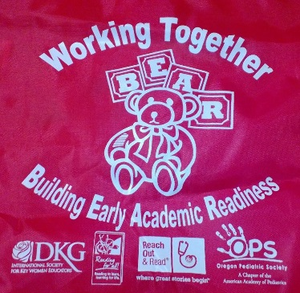
A local Delta Kappa Gamma chapter, local businesses/organizations, schools and children’s medical clinics “working together” can definitely make a difference in the educational progress of a child. I hope your community wants to “work together” to make this happen!
Good luck to your community!
Kathy Martell, Oregon State President
The Delta Kappa Gamma Society International
kkm4dkg@gmail.com

Working Together …….. Building Early Academic Readiness

